# Granting Privileges and Altering Attributes in SQL

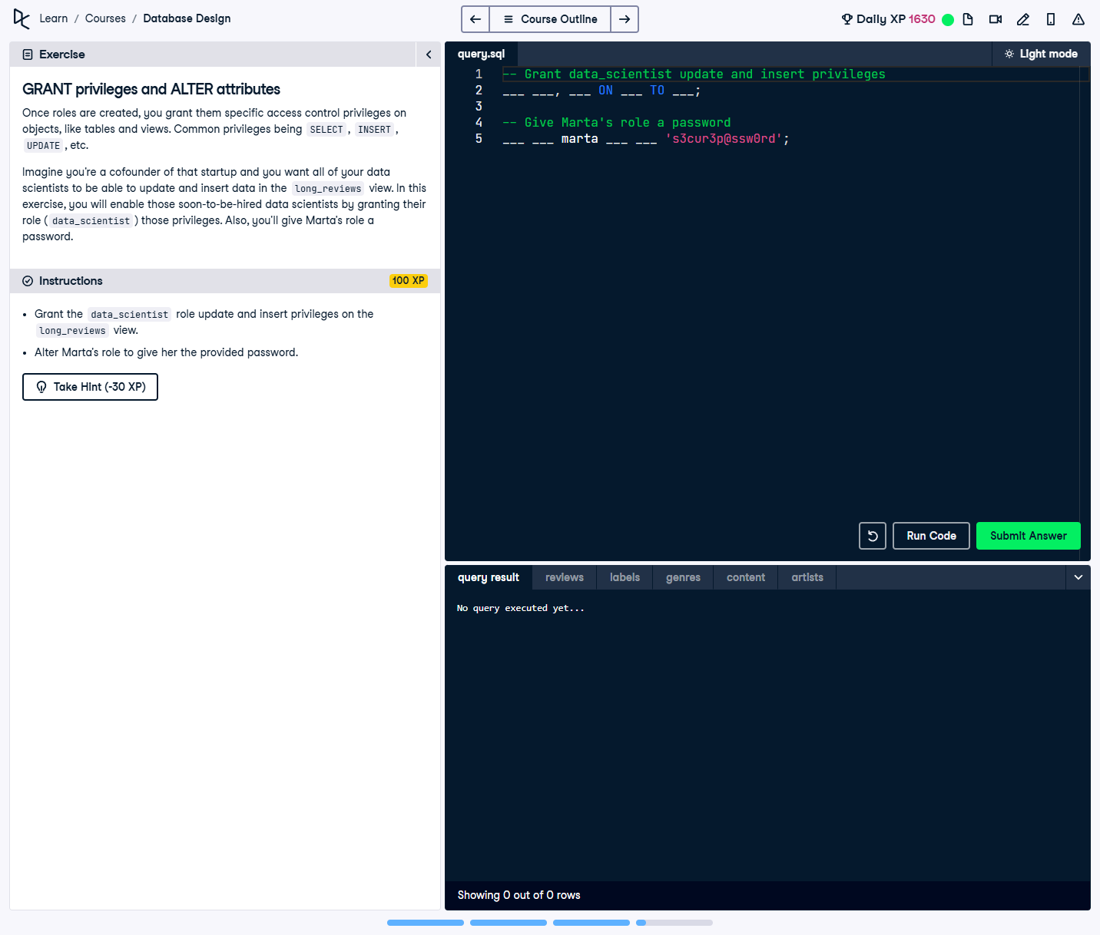

## Question:

Once roles are created, you grant them specific access control privileges on objects like tables and views. In this exercise, you need to:  
1. Grant the `data_scientist` role `UPDATE` and `INSERT` privileges on the `long_reviews` view.  
2. Alter Marta's role to assign her the provided password.

## Full Answer (SQL Code):

-- Grant data_scientist update and insert privileges  
GRANT UPDATE, INSERT ON long_reviews TO data_scientist;  
  
-- Give Marta's role a password  
ALTER ROLE marta WITH PASSWORD 's3cur3p@ssw0rd';

## Explanation of the Answer:

The `GRANT` statement assigns `UPDATE` and `INSERT` privileges on the `long_reviews` view to the `data_scientist` role, enabling them to modify this data. The `ALTER ROLE` statement updates Marta’s role by setting a secure password, allowing her to authenticate.